Fact sheet
Dispute Resolution Services

Residential tenancy agreements can sometimes become a source of disagreement, particularly if any of the parties do not meet the terms of the tenancy agreement under the Residential Tenancies and Rooming Accommodation Act 2008 (the Act). The Residential Tenancies Authority (RTA) encourages tenants, lessors and agents to attempt to resolve disagreements themselves by talking to each other and finding out about their rights and responsibilities.

If a dispute arises about a bond refund or a breach of a tenancy agreement, the concerned tenant, lessor or agent should contact the RTA for information about the Act and the procedures to follow. The RTA’s dispute resolution service provides conciliation to help the parties resolve disputes if they are unable to do this themselves.

What do we do
The RTA’s dispute resolution service offers a range of services free of charge to assist tenants and lessors/agents to resolve disputes quickly and without the need for further legal action. Our aim is to assist the parties in resolving the dispute in a way which can mean a successful outcome for all.

The RTA’s conciliators may be able to help resolve the dispute with just a few telephone calls. We can provide information on the Act to the parties and can assess the best way of trying to resolve the dispute.

We can also arrange a face to face meeting or a telephone conference between the parties to the dispute and an impartial conciliator.

Under the Act, tenants, lessors and agents must attempt to resolve a dispute over bond refunds and other tenancy matters by lodging a Dispute resolution request (Form 16) with the RTA before they can apply to the Tribunal for a decision.

Participation in the service is voluntary. There are no penalties for not taking part in telephone negotiations or for not attending a conference with a conciliator.

How to use the service
Parties can use the RTA’s dispute resolution service simply by filling out and lodging by post or fax a Dispute resolution request form with Dispute Resolution Services.

What happens if an agreement is reached?
We can assist the parties to enter into a written agreement in the settlement of disputes. All tenancy related agreements reached must be consistent with the Act. These agreements then become a term of the tenancy agreement.

If the parties reach an agreement about the distribution of a bond, the conciliator will get all the relevant parties to the bond to sign a Refund of rental bond (Form 4). The RTA can then pay out the bond money in accordance with the agreement.

What happens if an agreement is not reached?
If the parties are not able to resolve the dispute, the RTA will issue a Notice of unresolved dispute which will allow the parties to apply to the Tribunal for a decision.

Urgent applications
In an urgent situation (these are specified in the Act) tenants and the lessor/agent can apply straight to the Tribunal without first lodging a Dispute resolution request form with the RTA.

Urgent applications include:
- termination orders, including short tenancy (moveable dwelling)
- not leaving when a Notice to leave (Form 12) or Notice of intention to leave (Form 13) has expired
- order to restrain a person from causing damage or injury
- excessive hardship, and
- proposed or existing tenancy database listings which don’t comply with the listing criteria or are inaccurate or unjust.

Urgent applications can also be made under some other sections of the Act. For further information you can contact the RTA, visit the website, contact QCAT or your local Magistrates Court.

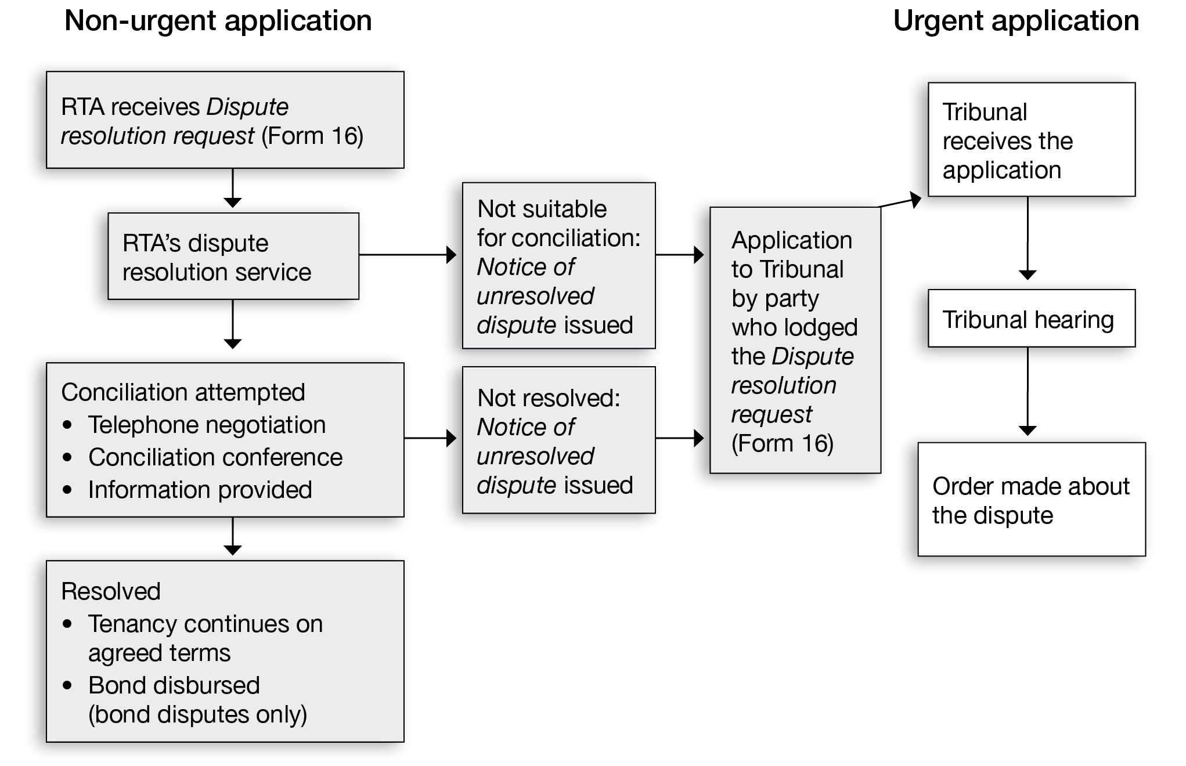

Further information
For more information contact the Residential Tenancies Authority on 1300 366 311.

Accessing RTA forms
The RTA’s forms can be obtained electronically or in person by:
- rta.qld.gov.au
- 1300 366 311
- Level 23, 179 Turbot St Brisbane

 | If you need interpreting assistance to help you understand this information, contact TIS on 13 14 50 (for the cost of a local call) and ask to speak to the Residential Tenancies Authority (RTA).


201 – v7 Oct12

